BBQ Meat Timer App

# App Overview

This app will apply cooking times for steaks depending on desired doneness. It will collect the number of steaks being cooked, at each desired doneness and create a plan for when steaks get placed on the grill, when they get flipped and when they are done.

Using the app will make sure all steaks are done, as requested and at the same time.

Version 1 will only be for steaks. Future versions may created for different types of meat.

Note, app works best if all steaks are close to the same thickness.

## Definitions

1. Doneness - defined as Rare, Medium Rare, Medium, Medium Well and Well Done. Related to the amount of redness in the finished steak. The app should include images of cooked steak as a guideline.
2. Total Cook TIme- the total cook time is the maximum time needed to cook one of the steaks to the desired doneness.
3. Flip Time - steaks cooked using this method are only flipped once. The flip time is one of the milestones in the cooking.

# Screens

1. Splash screen - shown while loading app
2. Steak Doneness Screen - shows images of steak at the various level of doneness, allows user to scroll down through images.
3. Session create- screen to allow user to add a steak, it’s thickness and level of desired doneness. Once added user can hit a “plus” sign to quickly add another steak at that level.
4. Preview screen. Once all steaks are added a preview of the cooktime is shown with each step in the process. Screen will have a “Start” button once the cook is ready.
5. Session screen. Shows a countdown to the next major milestone (e.g. “Add 2 Medium steaks in 2 minutes”.
6. Phone should vibrate 15 seconds (configurable?) before the milestone.

# Cooktime Logic

All cooktimes are based on this chart:

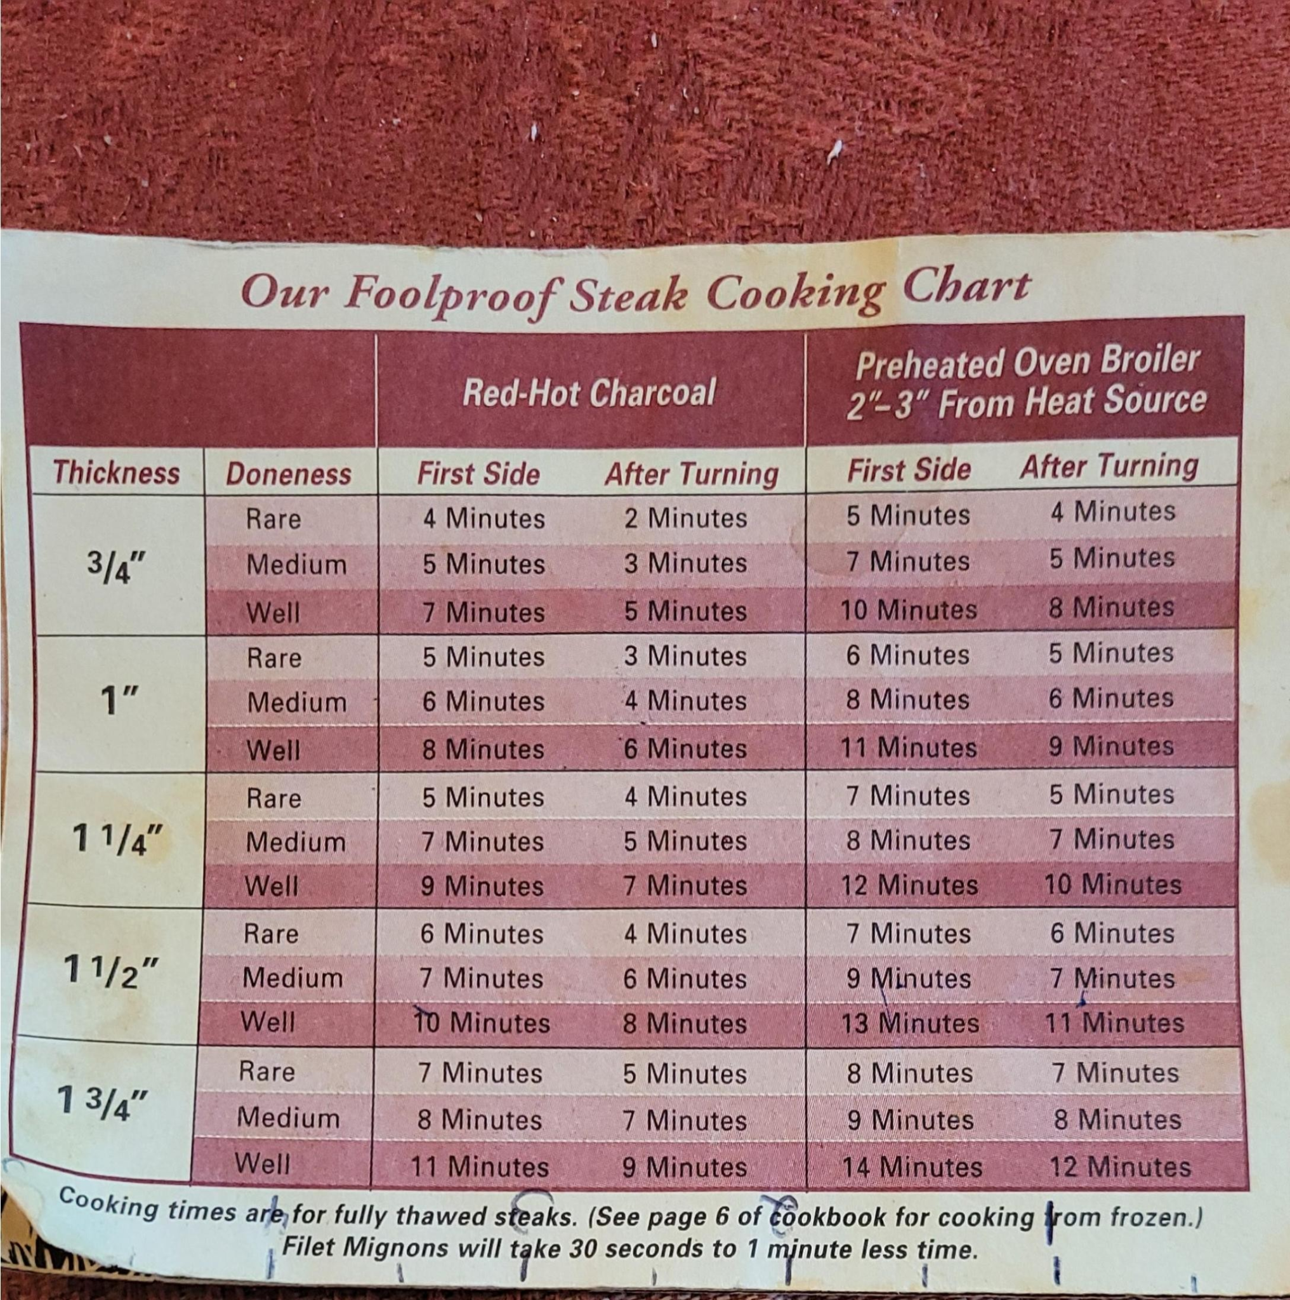

Follow this example below to understand the cook time logic. In this example we’re cooking 2 steaks, 1 Well Done and 1 Rare. The steaks are about 1.5” thick and we;re cooking on a gas BBQ.

1. Find the max total cook time which would be 18 minutes for the Well done steak.
2. Find the flip time for Well Done steak by subtracting the “After Turning” time from total cook time (18 - 8). So the well done steak get;s flipped at minute 10 of cooking.
3. Find the flip time for the Rare steak by subtracting the “After Turning” time of 4 from the total cooking time (18-4). So the Rare steak is flipped at time 14.
4. Finally compute the start time (aka “On”) for the Rare steak as the flip time - first side time (6 minutes). So the Rare steak gets put on the fire at 14-6 or 8 minutes into the cook.
5. The Well done state “On” time is time 0.

This table shoes all the milestones in this cook session:

|  | **0** | **1** | **2** | **3** | **4** | **5** | **6** | **7** | **8** | **9** | **10** | **11** | **12** | **13** | **14** | **15** | **16** | **17** | **18** |
| --- | --- | --- | --- | --- | --- | --- | --- | --- | --- | --- | --- | --- | --- | --- | --- | --- | --- | --- | --- |
| W | S |  |  |  |  |  |  |  |  |  | F |  |  |  |  |  |  |  | D |
| R |  |  |  |  |  |  |  |  | S |  |  |  |  |  | F |  |  |  | D |
|  |  |  |  |  |  |  |  |  |  |  |  |  |  |  |  |  |  |  |  |

s=start cook

f=flip steak

d=done cooking

The user needs to be warned at each of the highlighted cooking milestones.

Full timings (with Medium Well and Medium Rare) will here.